INVENTION DISCLOSURE FORM
INNOTECH PROJECT ID
DEPARTMENT
Ques.1. Title of your invention:
Using existing CCTV network for crowd management, crime prevention, and work monitoring using AI/ML
Ques.2. Type of Invention: Software
Ques.3. Brief Description of your invention
This invention integrates AI and Machine Learning (ML) into railway surveillance to automate security monitoring, crowd management, and operational oversight using real-time CCTV footage analysis. AI models like ResNet50 and OpenCV detect suspicious activities, overcrowding, unattended baggage, and staff inefficiencies. The system generates instant alerts, extracts video clips of anomalies, and provides security teams with actionable insights, improving railway safety and efficiency
Ques.4. Objective of your invention
- Enhance Railway Security: AI-powered surveillance for real-time crime detection.
- Efficient Crowd Management: Monitor passenger density and prevent overcrowding.
- Automated Work Monitoring: Ensure compliance with maintenance and safety standards.
- Real-Time Alerts: Generate notifications and emergency responses for security threats.
- Scalability & Integration: Expand to multiple stations and integrate with railway operations.
Ques.5. How to use the invention
- CCTV Feeds Processing: The system analyzes real-time video footage using ML models.
- AI-Powered Anomaly Detection: Identifies security threats, crowding, and operational inefficiencies.
- Automated Alerts & Reporting: Security personnel receive instant notifications and video clips.
- Dashboard Monitoring: Railway authorities track system insights via an interactive web portal.
- Emergency Integration: The system enables one-click emergency response activation.
Ques.6. Problem your invention is solving
- Manual Surveillance Limitations: Traditional railway monitoring is slow and error-prone.
- Crime & Security Issues: AI enhances real-time crime detection and incident response.
- Overcrowding & Passenger Safety: Predicts congestion and assists in smooth crowd management.
- Workforce Efficiency: Automates railway staff monitoring for maintenance and safety compliance.
Ques.7. Purpose and object of Invention
- Ensure safer railway environments through AI-driven monitoring.
- Improve operational efficiency by automating security and staff oversight.
- Enhance passenger experience with seamless railway station management.
- Support future scalability with additional features like predictive maintenance.
Ques.8. Discuss potential commercial application of the invention.
- Railway Safety & Surveillance Industry: Used for railway security enhancement and crime prevention.
- Smart City & Public Transport Management: Integration into metro stations, bus terminals, and airports.
- Predictive Maintenance Market: AI-driven analysis to optimize railway infrastructure maintenance.
- Public Sector & Government Adoption: Can be deployed in national railway and metro projects.
Ques.9. Provide any additional material (such as photographs, reports, publications, and references to texts or other information material) which may be helpful to an understanding of the invention identify and indicate the specific relevance of each.
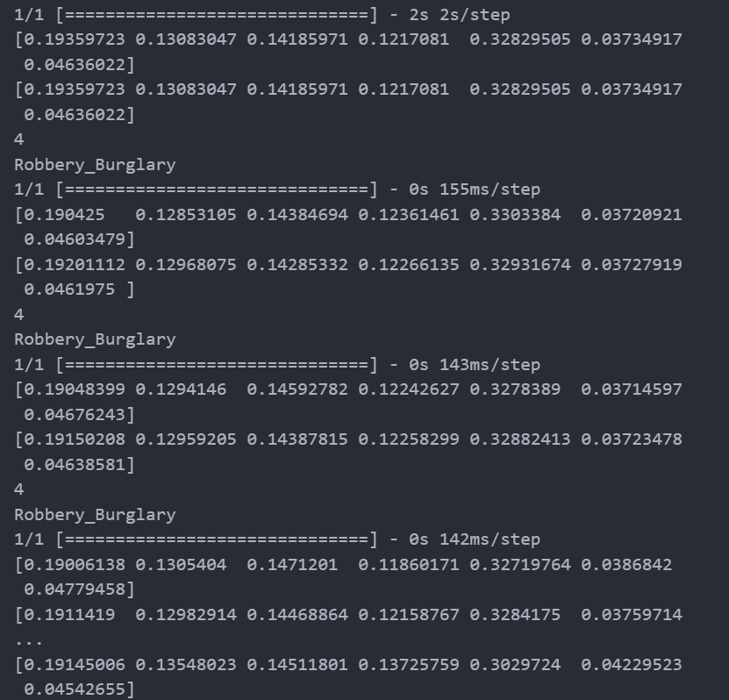
References: https://www.researchgate.net/publication/371011893_Deep_Learning_Models_for_Crime_Intention_Detection_Using_Object_Detection
https://www.sciencedirect.com/science/article/pii/S2667305323001369

Ques.10. Abstract
This AI-powered railway surveillance system leverages Machine Learning and Computer Vision to process real-time CCTV footage for crime detection, crowd management, and work monitoring. Using ResNet50, OpenCV, and real-time analytics, the system detects anomalies and generates instant alerts with video evidence. The platform integrates with emergency response services, allowing quick action on security threats or medical incidents. Designed for scalability, it supports multi-station deployment and predictive maintenance integration.
Ques.11. Summary of the invention
The system processes CCTV feeds in real-time, identifying security risks, operational inefficiencies, and passenger movement patterns. AI models automate anomaly detection, reducing human error and response delays. Security personnel receive alerts with video clips, enabling faster decision-making. The solution is scalable, privacy-compliant, and designed for seamless integration into railway infrastructure.
Ques.12. Detail description of invention with methodology
- Data Collection & Processing:
- Real-time CCTV footage is fed into the system for AI-based analysis.
- Frames are extracted and preprocessed using OpenCV.
- AI-Based Detection & Analysis:
- ResNet50 CNN Model is used to classify suspicious activities, overcrowding, and unattended baggage.
- ML algorithms predict crowd density to optimize station management.
- Automated Alert Generation:
- When an anomaly is detected, an alert is triggered with a video clip.
- Notifications are sent to security personnel via web dashboards and mobile devices.
- Emergency Response & Reporting:
- The system supports one-click emergency service integration (e.g., medical assistance, police alerts).
- Incident reports are logged for audit and future model training improvements.

Ques.13. Applicant and inventor details:
Aarohi Saxena
Roll no: 2200291520002

